Kosher Computer.
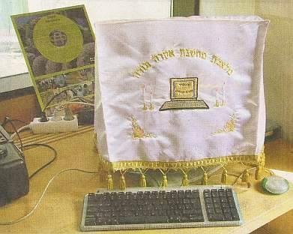
I don't know if you know this, but you can now purchase Kosher computers! They are made in Israel by a company called DELL-SHALOM. The price is so low, even with the shipping from Israel ! However, before you purchase a kosher computer of your own, you should know that there are some important changes from the typical non-kosher computer you are used to, such as:
01) The "Start" button has been replaced with a "Let's go! I'm not getting any younger!" button.
02) You hear "Hava Nagila" during startup.
03) The cursor moves from right to left.
04) When Spell-checker finds an error it prompts, "Is this the best you can do?"
05) When you look at erotic images, your computer says, "If your mother knew you did this, she would die."
06) It comes with a "monitor cleaning solution" from Manischewitz that gets rid of all the "schmutz und drek."
07) When running "Scan Disk" it prompts you with a "You want I should fix this?" message.
08) After 20 minutes of no activity, your PC goes "Schloffen."
09) The PC shuts down automatically at sundown on Friday evenings.
10) It comes with two hard drives -- one for fleyshedik (business software) and one for milchedik (games).
11) Instead of getting a "General Protection Fault" error, your PC now gets "Ferklempt."
12) The multimedia player has been renamed to "Nu, so play my music already!"
13) When your PC is working too hard, you occasionally hear a loud "Oy Gevalt!"
14) Computer viruses can now be cured with matzo ball soup.
15) When disconnecting external devices from the PC, you are instructed to "Remove the cable from the PC's tuchus."
16) After your computer dies, you have to dispose of it within 24 hours.
17) But best of all, if you have a kosher computer, you can't get SPAM.

